

School of InfoComm Technology

Data Virtualization
Diploma in Data Science (DS)
2025 Oct Semester

INDIVIDUAL ASSIGNMENT
(40% of Module)

09 Jan 2026 – 01 Feb 2026

Deadline for Submission:
Denodo Database File, Report and PowerPoint Slides: 01 Feb 2026 (Sun), 2359hrs

Student Name | : | Tiffany Loy Zhen Min
Student Number | : | S10266970K

Penalty for late submission:
10% of the marks will be deducted every day after the deadline.
NO submission will be accepted after 08 Feb 2026, 23:59.

Contents
1. Introduction 4
1.1 Background 4
1.2 Problem Statement 4
2. Data Sources and Base Views 6
2.1 Selected Data Sources and Rationale 6
2.2 Creation of Data Sources in Denodo 7
2.3 Base View Design and Structure 8
2.4 Initial Data Observations 8
3. Feature Engineering and Integrated Views 10
3.1 Integrated View 1 – iv_products_by_category 10
3.2 Integrated View 2 – iv_sales 11
3.3 Integrated View 3: iv_store_orders 12
3.4 Integrated View 4: iv_sales_by_orders_inventory 14
3.5 Integrated View 5: iv_store_product_summary 16
4. Final Integrated View 18
4.1 CSV Selected 18
4.2 Aggregated Fields 19
4.3 Purpose of Report View 19
5. REST …………... 20
5.1 Why REST 20
5.2 Steps Taken and Filtering 21
5.3 Sample of Functionality 22
6. Summary and Improvements 24
6.1 Summary of Key Findings 24
6.2 Reflection 24
6.3 Further Improvements 25

Introduction

Background

In the increasingly data-driven retail sector, prompt access to precise information is crucial for making wise decisions. For a bike retail company that has multiple stores, business data is generated from various operational activities like sales transactions, inventory management, product cataloguing and also customer preferences and interactions. Relational structures are frequently used to store this data across several tables, each with a distinct operational function.
Even though getting data for business insights is easy, there are many challenges when it is scattered across different views without a combined analytical perspective. Store managers and operations teams need gathered information to keep track of sales trends, assess product performance, and manage inventory levels in various stores. Decision-making can be delayed by the time-consuming process of extracting valuable insights from disparate perspectives, which may necessitate manual data preparation.

Data virtualization offers a solution by allowing the integration of data from various sources without moving or duplicating the data physically. By using data virtualization platforms like Denodo, companies can create unified, real-time views of their data. This allows stakeholders to access consistent and current information.

Problem Statement

The bike retail company maintains its operational data across multiple datasets, including orders, order items, products, stocks, staffs and more. Although each dataset is individually useful, the lack of integration results in fragmented information that limits insights about the company’s overall business performance.

As a result, store managers and operations teams struggle to clearly understand whether inventory levels at each store match actual customer demand. Some products may sell quickly at certain stores but remain overstocked at others, while popular products may run out of stock in high-demand locations. Identifying these mismatches currently requires manual consolidation of data from multiple datasets, which is inefficient and leads to slower responses to changing demand patterns.

These inefficiencies can negatively affect customer satisfaction, as customers may not be able to purchase the products they want at their preferred store. Over time, this can lead to lost sales opportunities and reduced customer retention.

This assignment aims to help store managers and operations teams gain a unified, store-level, and near real-time view of customer demand and inventory distribution across retail outlets to ensure customer needs, improving customer satisfaction. By integrating sales, inventory, and product category data using a data virtualization approach, the solution supports better inventory planning, improves product availability across stores, and ultimately enhances customer satisfaction and retention.

Data Sources and Base Views

Selected Data Sources and Rationale
The following selected data sources were chosen to support sales performance analysis and inventory monitoring across stores. They each have their individual purpose and together, these datasets enable the integration of sales demand and stock availability. It addresses the challenge of fragmented operational data and supports informed decision-making for store managers and operations teams.

- orders: To have order-level sales transactions, including order dates and store information, allowing sales trends to be analysed over time and compared across locations.

- order_items: Detailed information on products sold, as well as quantities and pricing details. It is essential for calculating overall sales volume, profits and determining top-selling products.

- products: Has descriptive information about each product, like name, supporting product-level analysis.

- categories: Classification of products into their groups, allowing demand patterns to be analysed at a categorical level.

- stocks: Records inventory levels for each product at the different stores. It is crucial for identifying stock shortages against demand.

- stores: Has information about store locations, enabling comparison of sales and inventory performance across the different stores, supporting location based analysis.

Creation of Data Sources in Denodo
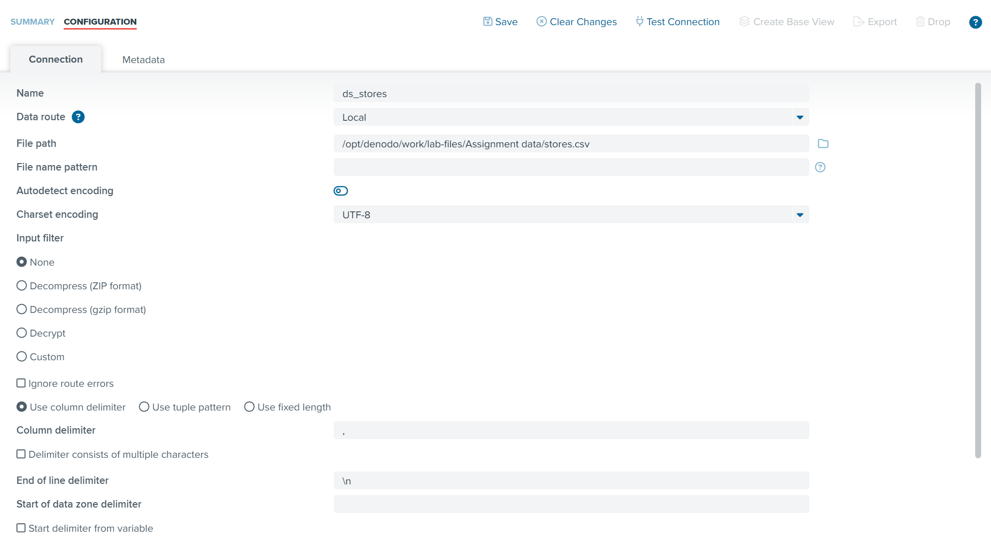

All datasets were loaded into Denodo as local CSV data sources using the delimited file option. Standard CSV configuration settings were applied, including UTF-8 encoding and comma delimiters. Additionally, I made sure to tick the headings box to ensure that the first row of each dataset becomes the dataset’s header.
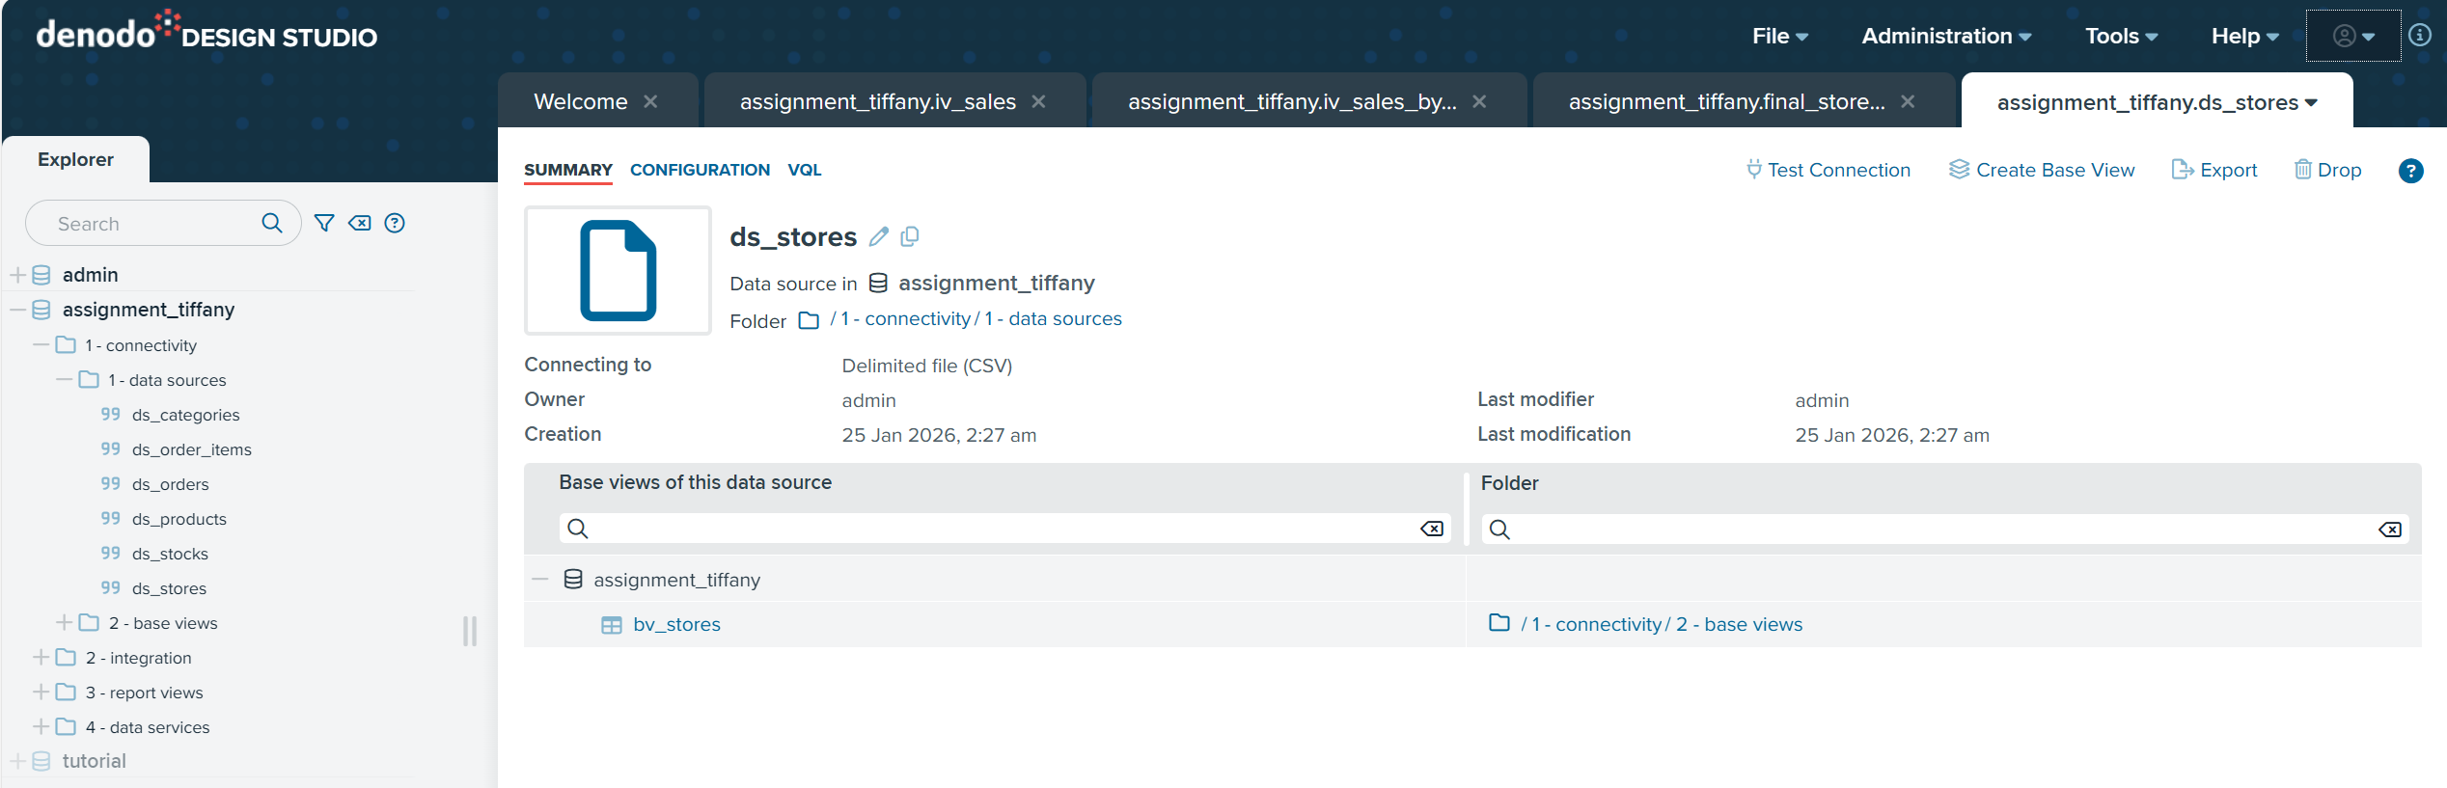
After testing each data source connection, base views were created directly from the data sources using Denodo’s Create Base View functionality. This approach allows Denodo to virtualize the data structure without physically importing the data. All base views were stored under the 1 – connectivity / 2 – base views folder. These base views become the foundational layer for subsequent data integration and analysis.

Base View Design and Structure

The base views were designed to closely reflect the original source data while ensuring appropriate data typing. Identifier fields were retained as text to support consistent joins across views. Numeric fields such as quantities and prices were defined using integer and double types respectively. Date fields were converted from text to date data types to enable time-based analysis in later stages.
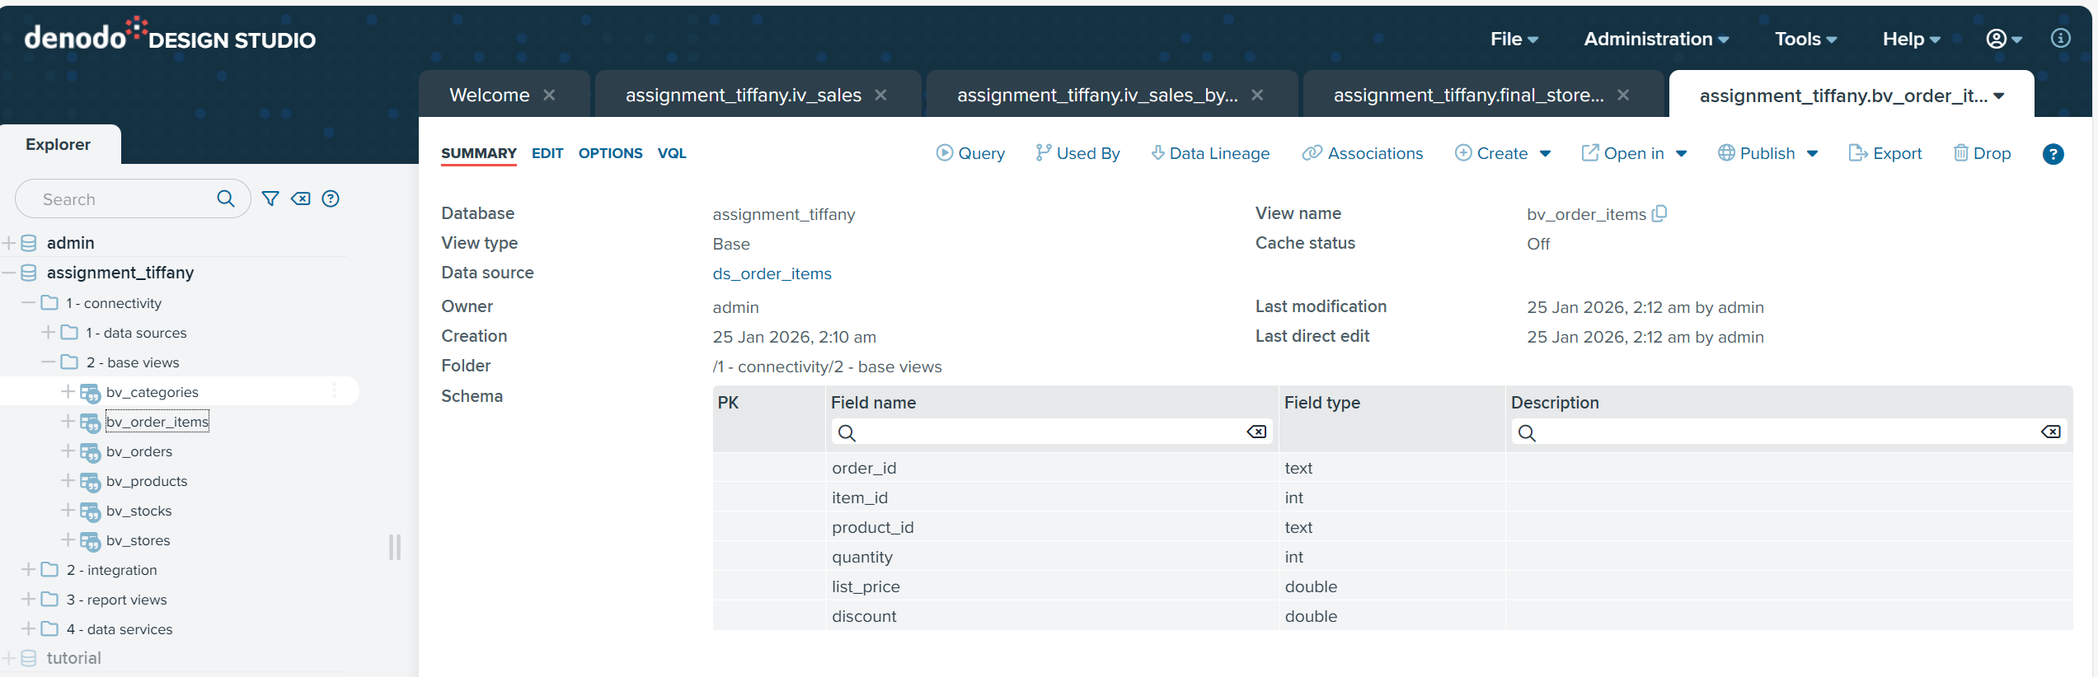
For bv_order_items, item_id and quantity were changed to int, while list_price and discount were changed to double. For bv_orders, order_date, required_date, and shipped_date were changed to LocalDate. For bv_products, model_year was changed to int and list_price was changed to double, while bv_stocks quantity was changed to int. No changes were made for bv_categories and bv_stores.

In general, all IDs were kept as text as they are identifiers used mainly for joining tables. Fields changed to int represent countable units, fields changed to double require decimal precision, and fields changed to LocalDate support time-based grouping, sorting, and filtering. These data type decisions ensure consistency across datasets and provide a reliable foundation for integrating sales demand and inventory data in later stages.

Initial Data Observations

Initial exploration of the base views revealed that sales transactions span multiple years and involve a wide range of products across different categories. Stock levels vary significantly across stores, suggesting the potential for uneven inventory distribution relative to customer demand. These early observations highlighted the importance of integrating sales and inventory data to support better demand analysis and more effective inventory allocation.

Feature Engineering and Integrated Views

Integrated View 1 – iv_products_by_category

This integrated view was created to enrich product data with its corresponding category and brand information, forming a single product dimension for analysis. This supports clearer understanding of how different product categories and brands contribute to sales and demand across stores.
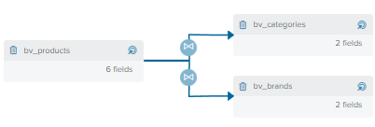

The view was built by joining the products dataset with categories and brands using their respective identifiers. This ensures each product record includes both its category and brand context.

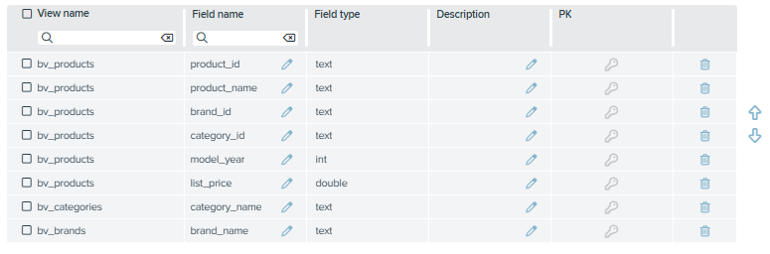

Overlapping columns brand_id and category_id were removed from their respective table to ensure joining on the products table. The final view retains product name, category name, brand name, and key pricing attributes, providing a clean and consistent dataset for downstream sales and inventory analysis.

Integrated View 2 – iv_sales

This integrated view was created to capture customer demand and sales revenue at the product level. By combining order item details with enriched product information, it enables analysis of how different products, categories, and brands contribute to overall sales performance.
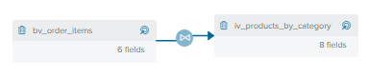

The view was built by joining the order items dataset with the product dimension view using the product identifier.
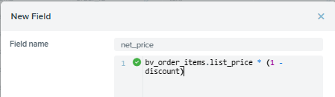

Calculated field net_price was added to calculate the price after discount.
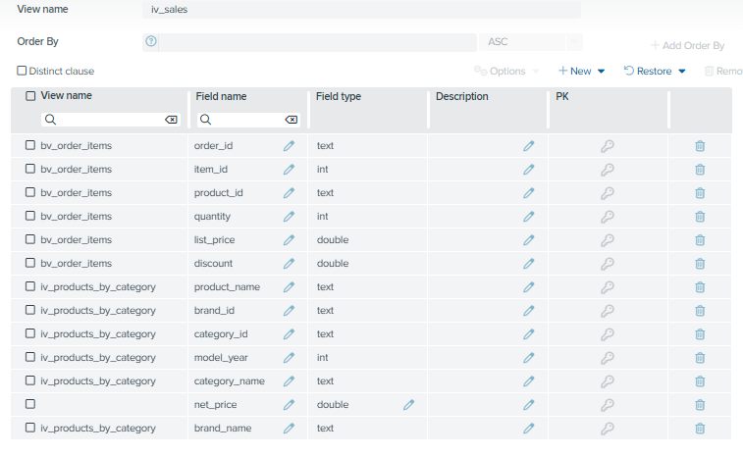

Like above, overlapping columns product_id and list_price were removed from iv_products_by_category. The final view retains product, brand, category, quantity, net price, and sales amount for downstream aggregation and inventory analysis.

Integrated View 3: iv_store_orders

This integrated view was created to provide store and time context for each sales order, enabling comparison of sales activity across different retail locations and time periods.
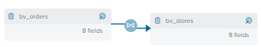

The view was built by joining the orders dataset with the stores dataset using the store identifier.

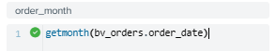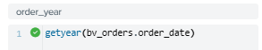

Derived fields were added to extract the order year and order month from the order date to support time-based analysis.

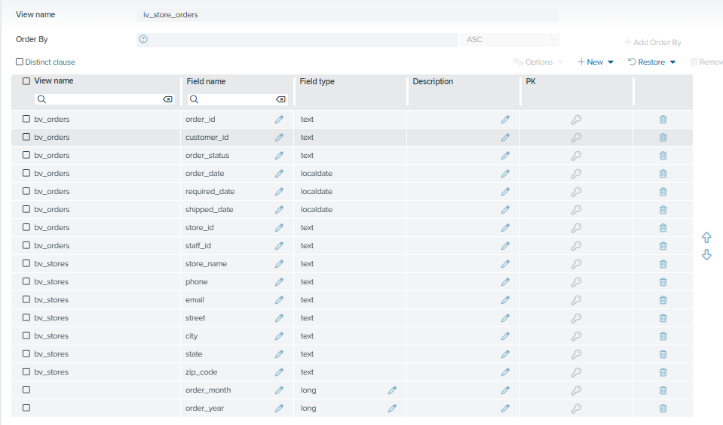

Overlapping field store_id was removed from bv_stores. The final view retains order details, store information, and time attributes, forming a clean base for downstream sales and inventory integration.

Integrated View 4: iv_sales_by_orders_inventory

This integrated view was created to combine customer demand, store context, and inventory information at the store–product level. It provides a detailed foundation for analysing how sales performance aligns with available stock across different store locations.
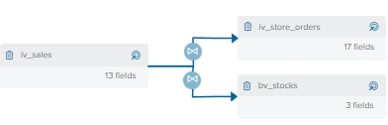

The view was built by first joining the sales view with the store orders view using the order identifier. The resulting dataset was then joined with the inventory dataset using both product and store identifiers.

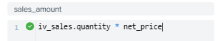

A calculated field was included to represent sales amount at the transaction level.
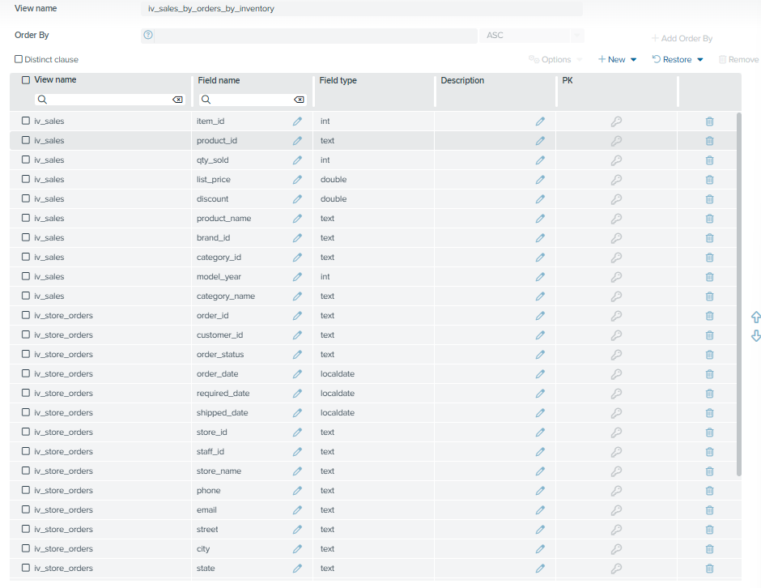
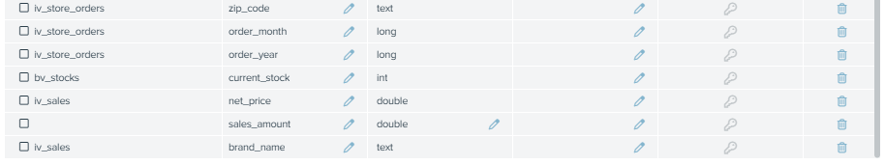

Overlapping fields store_id and product_id were removed from bv_stocks, order_id was removed from iv_sales. bv_stocks.quantity was renamed to current_stock and iv_sales.quantity was renamed to qty_sold. The final view retains sales, store, and stock fields required for downstream aggregation and stock status analysis.

Integrated View 5: iv_store_product_summary

This aggregation view was created to summarise customer demand and inventory levels at the store–product–brand level. It provides a single, consolidated view that supports comparison of sales performance and stock availability across different stores and time periods.

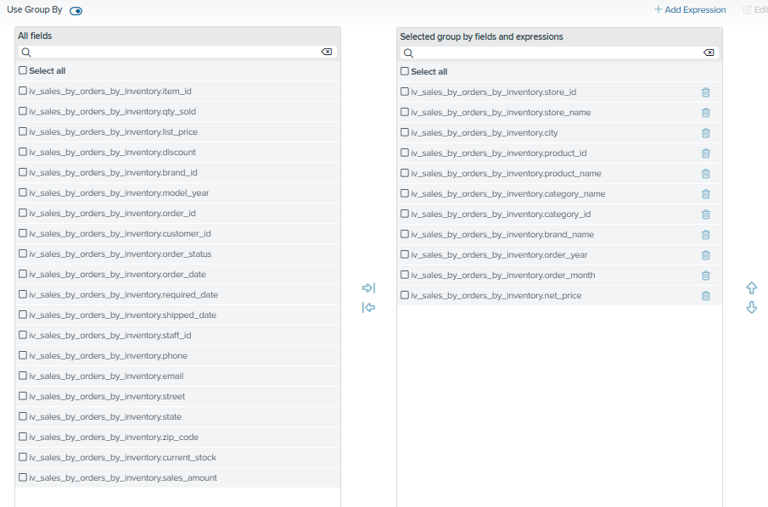

The view was built by aggregating data from the detailed sales and inventory view. Sales quantity and revenue were summed, while inventory levels were retained using an aggregate function. Fields such as store, product, category, brand, and time were grouped to ensure one row represents demand and stock for a specific product and brand at a store within a given period.
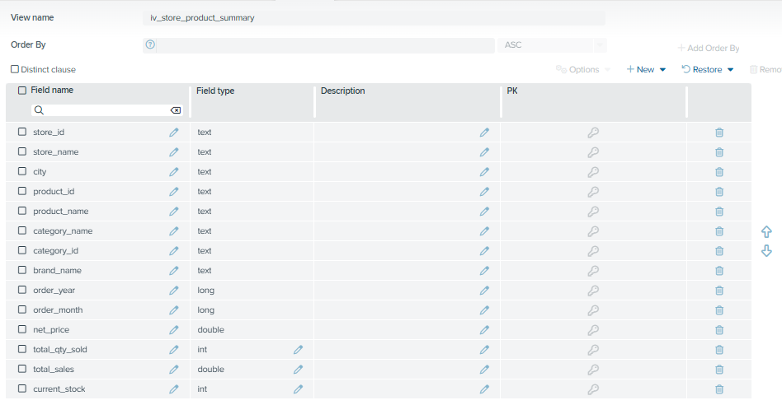

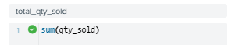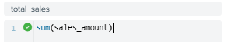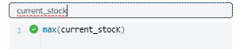

The final view contains total quantity sold, total sales, current stock, and supporting attributes for downstream reporting and stock status analysis.

Final Integrated View
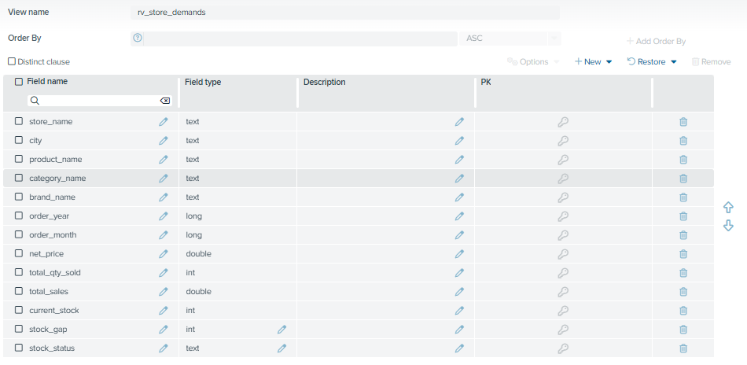

CSV Selected

This report view rv_store_demands is derived from multiple CSV datasets, including orders.csv, order_items.csv, products.csv, categories.csv, brands.csv, stocks.csv, and stores.csv. These datasets collectively provide information on customer purchases, product and brand attributes, inventory levels, and store locations. Together, they form the foundation for analysing customer demand against available stock across different retail outlets.

The selected datasets were chosen to support a holistic comparison between sales demand and inventory availability at the store level. Sales-related datasets orders and order_items capture customer demand, while products, categories, and brands provide meaningful product context. The stocks dataset supplies current inventory levels, and stores enables location-based analysis. This combination allows store managers to understand not just what is selling, but where and under which brand and category.

Aggregated Fields

Derived fields including stock_gap, and stock_status translate the previously created aggregated fields into actionable insights, allowing quick identification of stock shortages, balanced inventory, and overstocked situations.

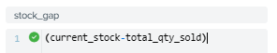

The stock_gap field is calculated as the difference between current stock and total quantity sold. A negative value indicates that demand exceeds available stock, while a positive value suggests excess inventory.
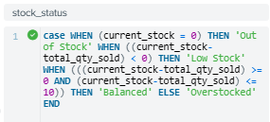

The stock_status field translates numeric indicators into actionable categories. Products with zero stock are labelled Out of Stock. When demand exceeds stock, the status is Low Stock. If stock levels fall within a small buffer range, the status is Balanced. Products with significantly higher stock than demand are classified as Overstocked.

Together, these derived fields transform raw sales and inventory data into clear, actionable insights that support faster and more informed inventory decisions.

Purpose of Report View

The purpose of this report view is to address the lack of an integrated perspective on customer demand and inventory distribution across stores, as outlined in the problem statement. Store managers and operations teams previously had to manually combine data from multiple sources to determine whether stock levels aligned with actual customer demand, resulting in slow and inefficient decision-making.

This report view provides a unified, store-level, and near real-time view of product and brand performance by consolidating sales, inventory, and store information into a single dataset. It enables stakeholders to quickly identify products and brands that are understocked or overstocked at specific locations, allowing inventory adjustments to be made more proactively. By improving visibility into demand–stock mismatches, the report view supports better inventory planning, reduces stockouts, and ensures products are available where customers expect them, ultimately improving customer satisfaction and retention.

REST

Why REST

REST was used to expose the final report view (rv_store_demands) as a reusable and real-time data service that can be accessed beyond the Denodo Design Studio environment. In the context of the problem statement, store managers and operations teams previously faced delays due to fragmented data and manual querying when attempting to assess whether inventory levels matched customer demand at individual stores. By deploying the final integrated view as a REST service, demand and inventory insights can be retrieved on demand through a simple HTTP request, without requiring users to directly access Denodo or understand its internal data model.

Using REST also supports operational scalability. As the data model grows or new stores are added, the same REST endpoint can continue to serve updated information without changes to downstream applications. JSON was selected as the default response format because it is lightweight, widely supported, and easy to integrate into dashboards, reporting tools, or operational systems. Overall, REST enables faster access to actionable insights, reduces dependency on manual analysis, and supports timely decision-making related to inventory planning, directly addressing the inefficiencies highlighted in the problem statement.

Steps Taken and Filtering

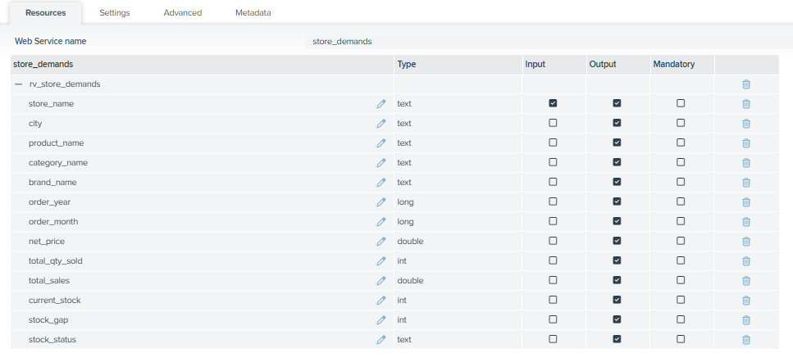

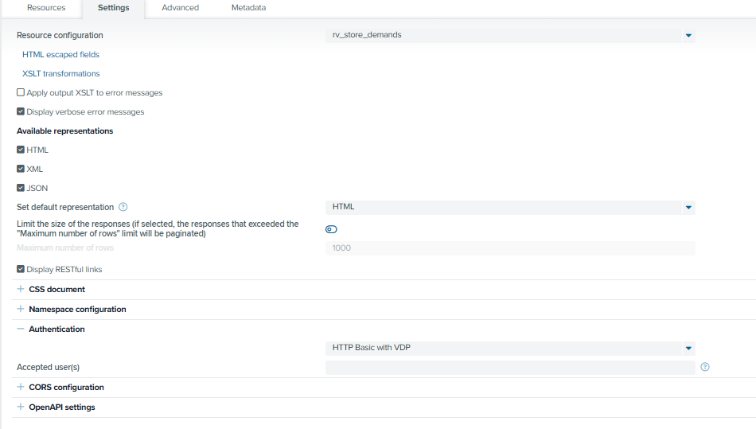The REST service was implemented using Denodo’s Web Services Container to ensure the service is hosted via a localhost endpoint. The final report view (rv_store_demands) was added as a REST resource, with JSON configured as the default response format. Pagination was enabled to manage large result sets, and HTTP Basic authentication with VDP was applied to ensure secure access while keeping the configuration simple and appropriate for an academic environment.

To support store-specific analysis, the store_name field was enabled as an input parameter. This allows users to filter results by individual store, aligning with real-world operational workflows where store managers typically focus on their own outlet. Enabling filtering reduces unnecessary data transfer and ensures that only relevant demand and inventory information is returned.

Sample of Functionality

URL: http://localhost:9090/server/assignment_tiffany/store_demands/
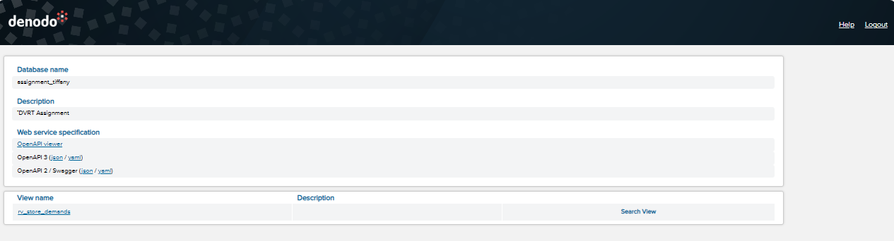

The REST service was tested by applying a filter condition where store_name is set to “Baldwin Bikes”. The service successfully returned JSON-formatted results showing product-level demand, current stock, stock gap, and stock status for the selected store. The output clearly identifies products that are overstocked or low in stock at Baldwin Bikes, demonstrating that the REST endpoint functions correctly and delivers actionable, store-specific insights as intended.
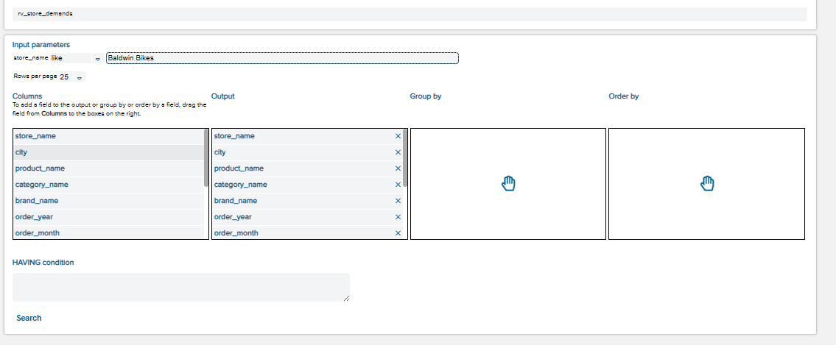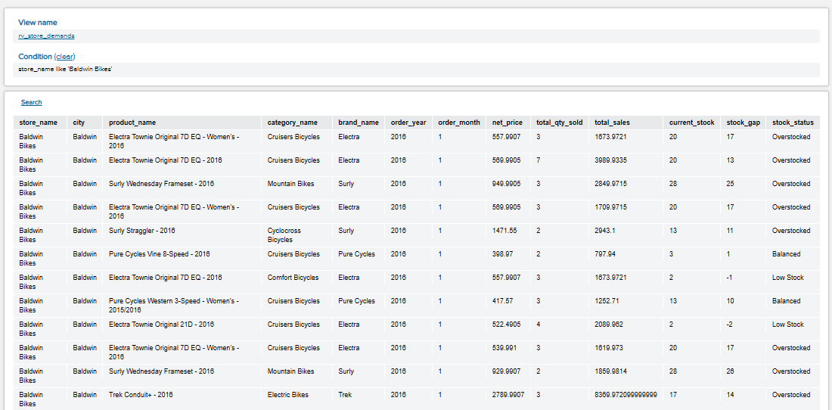

Summary and Improvements

Summary of Key Findings

Based on the final report view (rv_store_demands), the analysis directly addresses the problem statement of fragmented data and limited visibility into whether inventory levels align with actual customer demand at each store. By integrating sales, inventory, and product information into a single view, it becomes much easier to identify demand–stock mismatches that were previously difficult and time-consuming to detect.

The results show that a large number of products across different stores are classified as Overstocked, even though their total quantity sold is relatively low. In several cases, overstocked items recorded sales of only one or two units within the month, indicating weak demand. This highlights inefficient inventory allocation, where excess stock is being held for slow-moving products, tying up storage space and capital unnecessarily.

At the same time, some products are marked as Low Stock or Out of Stock, but their total quantity sold remains modest, often not exceeding five units. This suggests that while stock shortages exist, they do not always justify aggressive restocking. Instead, more targeted and moderate inventory adjustments would be sufficient to meet customer demand without creating further overstock situations.

These findings demonstrate that the main challenge is not simply stock shortages, but rather imbalanced inventory distribution across stores. The derived fields such as stock_gap and stock_status translate raw sales and inventory data into clear, actionable indicators. This allows store managers and operations teams to quickly identify which products require restocking, which should be redistributed to other stores, and which may not require further replenishment. As a result, the solution supports faster decision-making, improves product availability at the right locations, and helps prevent lost sales opportunities, directly addressing the issues outlined in the problem statement.

Reflection

Through this assignment, I gained a deeper understanding of how data virtualization can be used to solve real operational problems. Instead of physically moving or duplicating data, Denodo allowed me to integrate multiple datasets into a single, consistent analytical layer. Designing base views, integration views, and aggregation views helped me better appreciate the importance of layering and abstraction in data modelling.

Deploying the final report view as a REST service was especially valuable. It showed how analytical views can be operationalised and accessed by external systems through a simple URL, rather than remaining confined to the data platform. Configuring input parameters such as store_name also reinforced how REST services can support real-world use cases where users typically focus on a specific store.

Overall, this assignment helped bridge the gap between raw data integration and delivering actionable business insights.

Further Improvements

There are several areas where this solution can be enhanced further. First, historical trend analysis could be added by expanding the time window to include more months or years, allowing demand trends to be analysed over time rather than on a month-by-month basis. Second, automated restocking thresholds could be introduced based on historical demand instead of fixed buffer ranges.

Additionally, performance could be improved by enabling caching or materialisation for frequently accessed views. From a business perspective, integrating customer demographics or promotions data could provide deeper insights into why certain products perform better at specific stores. Finally, the REST service could be extended with additional filters such as brand or category to support more targeted analysis.

